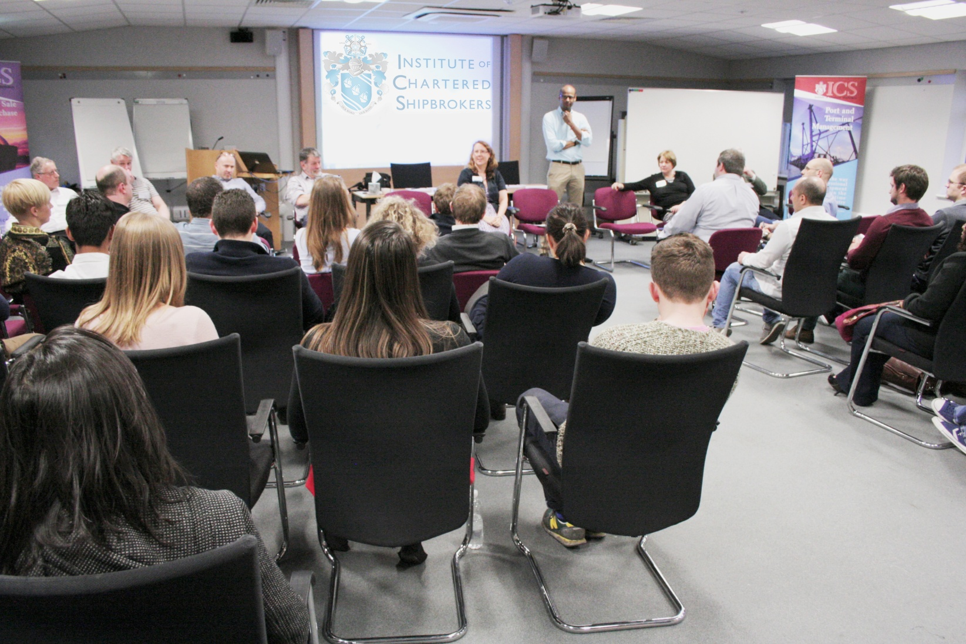
Spring PREP 2018
Thursday 5th to Sunday 8th April 2018 - University of Warwick
A study experience tailored specifically towards preparation for the Institute of Chartered Shipbrokers’ exams, open to all students irrespective of their method of study.  PREP provides students with an intensive, interactive and highly motivating study experience tailored specifically towards preparation for the Institute’s exams.  The revision event will include: mock exam, lectures, the opportunity for personal tutoring and networking. |  | 
‘I thoroughly enjoyed the weekend, both learning and socialising. I feel much more confident
about passing my exams and I hope to be back next year.’
Ricky, Clarksons Port Services

‘It was a perfect weekend of learning and socialising with colleagues from the industry.
Will definitely come back next year as it is a great way to prepare toward my exams.’
Jordi, Next Maritime Agency

‘I thoroughly enjoyed the PREP weekend. It exceeded my expectations for both the facilities,
the accommodation we stayed in and also the amount and quality of the information given out by the presenters and the Institute’s staff who made themselves available throughout the weekend. Can’t wait for next year.’
Mark, The Armitt Group

‘Everything about this year at PREP was fantastic. Every detail had been well thought through. The tutors are fantastic; the Institute’s staff very friendly and make you feel so welcome. The passion from all the staff and tutors is commendable and really shines through.’
Vikki, The Armitt Group
The Institute of Chartered Shipbrokers | 85 Gracechurch Street  London EC3V 0AA  United Kingdom |  | t. +44 (0) 20 7623 1111  f. +44 (0) 20 7623 8118  enquiries@ics.org.uk

Spring PREP 2018 Booking Form
PERSONAL DETAILS
PLEASE WRITE CLEARLY IN CAPITAL LETTERS (personal details as they appear on your passport)
Student number
Title (please circle) | Mr | Mrs | Miss | Ms | Dr |  | Capt
First name
Family name
Date of birth (dd/mm/yyyy)
Company name
Dietary requirements
BILLING ADDRESS
Address
City |  |  |  | Postcode |  |  |  |  | Country
Email address

Telephone number |  |  |  |  |  |  |  |  |  |  |  | Mobile number
PAYMENT OPTIONS
The cost of the residential course is £975.00 (discounted fee available for TutorShip students £825).
(Please tick one of the following options)
 |  | Card payment |  |  |  |  |  |  |  |  |  |  |  |  |  |  |  |  | Bank transfer |  |  |  |  |  |  |  |  |  |  |  |  |  |  |  |  |  |  |  |  |  | Cheque
 | We can process the payment over the phone for you. Please call us: +44 (0) 20 7623 1111  We accept the following cards:  Visa Credit/Debit and Mastercard. |  |  |  |  |  |  |  |  |  | HSBC:  1-3 Bishopsgate  London, EC2N 3AQ  Bank Sort Code 40-02-31  Account Number 11463810  Beneficiary name  Institute of Chartered Shipbrokers  Reference: PREP-YOUR SURNAME |  |  |  |  |  |  |  |  |  |  |  |  |  |  |  |  |  |  |  |  |  |  |  | Please make your cheque payable to ‘Institute of Chartered Shipbrokers’, and send it with this form to:  Institute of Chartered Shipbrokers  85 Gracechurch Street  London EC3V 0AA
 | DECLARATION
 | I hereby confirm that the information that I have provided is true and correct.
 | Date |  |  |  |  |  |  |  |  |  |  |  |  |  |  |  |  | Signature
 | Note: Cancellation terms apply. Please see the Institute of Chartered Shipbrokers refund policy on www.ics.org.uk
The Institute of Chartered Shipbrokers |  |  |  |  |  |  |  |  |  |  |  |  |  | 85 Gracechurch Street  London EC3V 0AA  United Kingdom |  |  |  |  |  |  |  |  |  |  |  |  |  |  |  |  |  |  |  |  |  | t. +44 (0) 20 7623 1111  f. +44 (0) 20 7623 8118  enquiries@ics.org.uk
Your PREP Weekend
The information below will help us to better organise the event, providing you with a more customised revision experience
Subjects available  at Spring PREP 2018 |  |  |  |  |  |  |  |  |  |  |  |  |  |  |  | Your examination subjects |  |  |  |  |  |  |  |  |  |  |  |  |  |  | Subjects you want to attend  at PREP
Introduction to Shipping  (Compulsory for Foundation Diploma) |  |  |  |  |  |  |  |  | Core subjects
Legal Principles in Shipping Business
Economics of Sea Transport & International Trade
Shipping Business
(Compulsory for Advanced Diploma)
Dry Cargo Chartering |  |  |  |  |  |  |  |  | Specialism
Ship Operations and Management
Ship Sale & Purchase
Tanker Chartering
Liner Trades
Logistics & Multi-modal Transport
Port Agency
Port & Terminal Management
Offshore Support Industry
Shipping Law
Marine Insurance
Shipping Finance
Note: In order to get the most out of PREP, we recommend that you attend no more than two subjects
The Institute of Chartered Shipbrokers |  |  |  |  |  |  |  |  |  |  |  |  | 85 Gracechurch Street  London EC3V 0AA  United Kingdom |  |  |  |  |  |  |  |  |  |  |  |  |  |  |  |  | t. +44 (0) 20 7623 1111  f. +44 (0) 20 7623 8118  enquiries@ics.org.uk

